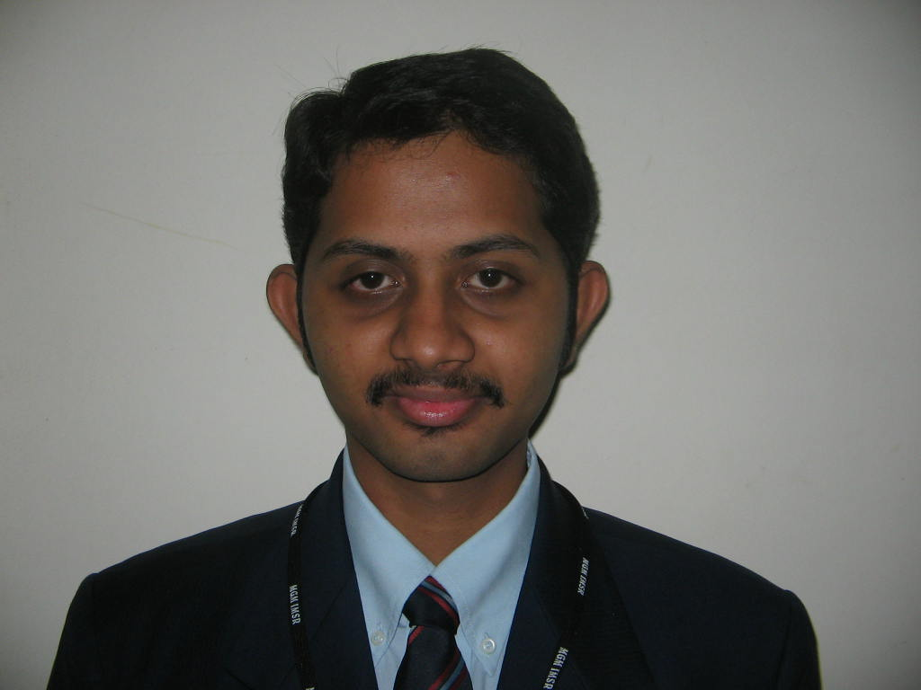

ARVIND RAMANARAYANAN MARKETING
Flat 106, Kunal-2, Plot: 206/207,
Email: arvindmgm04@yahoo.com
Contact No.
Res: 022-27714299
Mob: 9819083010
Sector 21, Nerul,
Navi Mumbai – 400706
Educational Qualifications

Degree | Institute | Board | Percentage
MMS (Sem III) | MGMIMSR | University of Mumbai | Currently pursuing
MMS (Sem I & II ) | MGMIMSR | University of Mumbai | 64%
Degree | SIES | University of Mumbai | 51.14%
HSC | Vivek College | Maharashtra Board | 55.83%
SSC | St.Xaviers School | Maharashtra Board | 57.06%

Additional Qualification

- Diploma in Travel & Tourism from IITC.
- IATA (approved by Montreal, Canada) from IITC
- Tally 5.4
Experience

Worked as a Customer Service Associate for a leading BPO firm WNS Pvt Ltd (a subsidiary of British Airways) with a work experience of 6 months.
Projects

Summer project: Worked in Air-India
Topic: Frequent Flyer Program of Air India

Achievements

- Have won Marathi Scholarships.

Personal Details

Date of Birth: 17th July 1982
Languages known: English, Hindi, Marathi, Tamil, Malayalam

